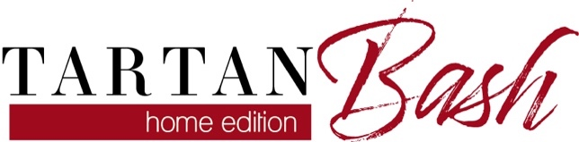

Sponsor and In-Kind Donation Delivery Options
Thank you for supporting the Mequon-Thiensville Education Foundation as a Tartan Bash sponsor or in-kind auction item donor. You’ll receive recognition before, during and after the event, details at mtef.org/donate. We hope you’ll join us on March 6th! Three donation delivery options for your convenience:

- Submit electronically
- mtef.org/donate-now (monetary) & mtef.org/sponsor (sponsor details)
- mtef.org/auctionform (in-kind certificate)

- Mail to MTEF, PO Box 514, Mequon, WI 53092
MTEF Bookkeeper Andi Zimmerman securely retrieves & distributes all mail
(alszimmerman@aol.com 414-520-2419‬)

If it ABSOLUTELY may not be sent to a PO Box, mail to MTEF’s official office: MTEF, Sue Birmingham, 5000 W Mequon Rd, Mequon, WI 53092 (suebirmingham@mtef.org 262-822-2824)

- Arrange for us to safely pick it up
MTEF Board Member Dr. Ellen Leeney will happily & safely retrieve it
(eleeney1992@gmail.com 414-640-6961)‬‬

More at mtef.org/donate
Thank you. Your donation helps students succeed.
The Foundation is a tax-exempt 501(c)(3) charitable organization (tax ID 31-1625167).

